**Data communication and computer networks lab**

**Semester:6th**



**Lab Report # 9**

**Submitted By:** *Zainab Khalid*

**Registration No:***19PWCSE1743*

**Section: A**

**Submitted to:** *Engr Faiz Ullah*

**Department of Computer Systems Engineering**

**University of Engineering and Technology Peshawar**

**LAB # 9**

|  |  |  |
| --- | --- | --- |
| **Criteria** | **Excellent** | **Marks Obtained** |
| 1. **Objectives of Lab** | All objectives of lab are properly covered  [Marks 0.5] |  |
| 1. **Introduction to Python Programming** | Brief introduction of Python Programming  [Marks 2] |  |
| 1. **Introduction to python socket library and its various functions** | Brief introduction about Socket library and its various functions used in Lab  [Marks 2] |  |
| 1. **Client-Server Communication using socket library** | Client-Server communication, Python code and output  [Marks 3] |  |
| 1. **Flowchart of client server communication using python socket library** | Draw a flowchart of the sequence of socket API calls and data flow for TCP  [Marks 2] |  |
| 1. **Conclusion** | Conclusion about RC-Circuit analysis  [Marks 0.5] |  |

**LAB # 9**

**TCP/IP Implementation using Python Socket Programming**

**Objectives of Lab:**

* Introduction to python
* To learn about socket programming

**Introduction to Python Programming:**

Python is a widely-used general-purpose, high-level programming language. It was designed with an emphasis on code readability, and its syntax allows programmers to express their concepts in fewer lines of code.

**Introduction to python socket library and its various functions**

Sockets and the socket API are used to send messages across a network. They provide a form of inter-process communication (IPC). The network can be a logical, local network to the computer or one that’s physically connected to an external network, with its own connections to other networks. The obvious example is the Internet, which you connect to via your ISP.

**Client-Server Communication using socket library**

**Server file:**

import socket  
  
s = socket.socket(socket.AF_INET, socket.SOCK_STREAM)  
s.bind((socket.gethostname(), 6061))  
s.listen(5)  
  
clientSoc, address = s.accept()  
  
print("\n Connection estblished : ", address)  
while True:  
 msg = input("Enter msg : ")  
  
 clientSoc.send(bytes(msg, 'utf-8'))  
clientSoc.close()

**Server-side output:**

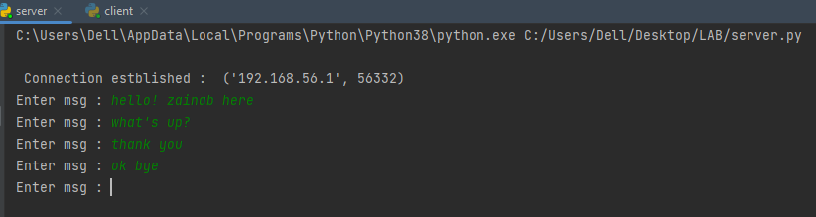

**Client file:**

import socket  
  
s = socket.socket(socket.AF_INET, socket.SOCK_STREAM)  
  
s.connect((socket.gethostname(), 6061))  
  
while True:  
 msg = s.recv(2024)  
 print("Message is : ", msg.decode())

**Client-side output:**

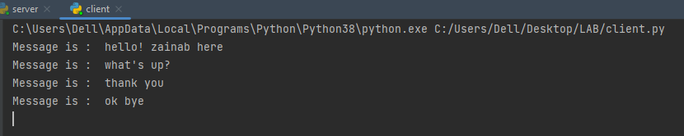

**Flowchart of client-server communication using python socket library**

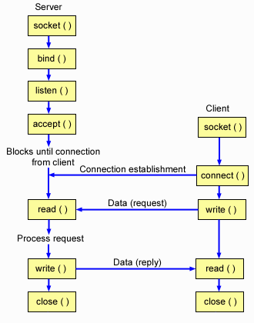

**Conclusion**

Client-server intercommunication is developed using socket programming. Both client and server can communicate with each other by TCP/IP protocol.